Module 3 Synopsis: Cybersecurity and Artificial Intelligence in Threat Detection
Unit 2.1
Artificial Intelligence Powered Threat Detection (20mins)
AI-powered threat detection refers to the use of artificial intelligence (AI) and machine learning (ML) technologies to automatically identify, analyze, and respond to cybersecurity threats in real-time or near-real-time.

Data is the New Firewall
Cybersecurity tools powered by AI rely on large volumes of data to detect and respond to threats. For example, threat classification system compares cyber activities to known malware signatures and patterns learned from billions of signals daily to detect malicious activities. Even if the malware is new (zero-day), the AI can classify it as likely malicious based on behavior.

Stages in AI-Powered Threat Detection
As depicted in figure 4, let us briefly look into the basic explanation of the stages involved in AI-powered threat detection pipeline based on data that are peculiar to threat detection.

Data Ingestion: This is the process of collecting and importing data from various sources into a data processing platform for further use, such as analysis, visualization, or machine learning.

Feature Extraction: The transformation of raw data into a set of measurable and meaningful characteristics (features) that can be used for analysis or modeling—especially in machine learning, pattern recognition, and data analysis.

Model Training: This involves making machine to learn from data, much like the way humans learn from past experiences

Model prediction: Refers to the process by which a machine learning or statistical model uses input data to produce an estimated outcome or result. The prediction is the model’s best guess based on patterns it has learned from training data.
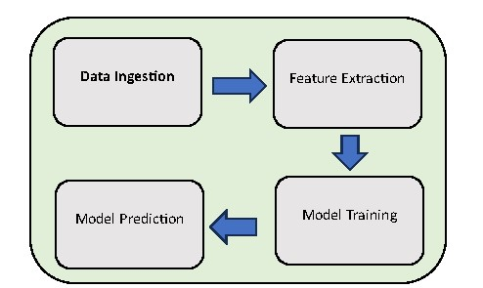

Figure 4: AI-Powered Threat Detection Pipeline
Unit 2.2
As shown in table 2, some of the data used in artificial intelligence and machine learning threat detection are briefly describe below: (30mins)

Table 2. Types of Data Used in Threat Detection
Data Type | Source | Example
Log Data | Firewalls, servers, network devices | Unusual login times
Packet Data | Network sniffers | Suspicious port scans
User Behavior | Applications, devices | Rapid file deletions
Email Content | Mail servers | Phishing keywords

Log Data: refers to the automatically recorded information generated by computer systems, applications, servers, or devices during their operations. It captures events, activities, and transactions that occur within a system, providing detailed records of what happened, when, and by whom or what.

Packet Data: refers to the small units of data that are transmitted over a computer network. When data is sent across networks (like the internet), it is broken down into packets, sent separately, and then reassembled at the destination.

User Behaviour: refers to the actions and patterns of activity displayed by users when interacting with a system, website, application, or network. It includes everything a user does—from clicks and keystrokes to login attempts and navigation paths.

Email Content: refers to the actual message included in an email. It consists of the written body and any embedded or attached elements, structured to convey a specific communication between the sender and the recipient.

Fun Fact: AI systems often analyze billions of events per day.
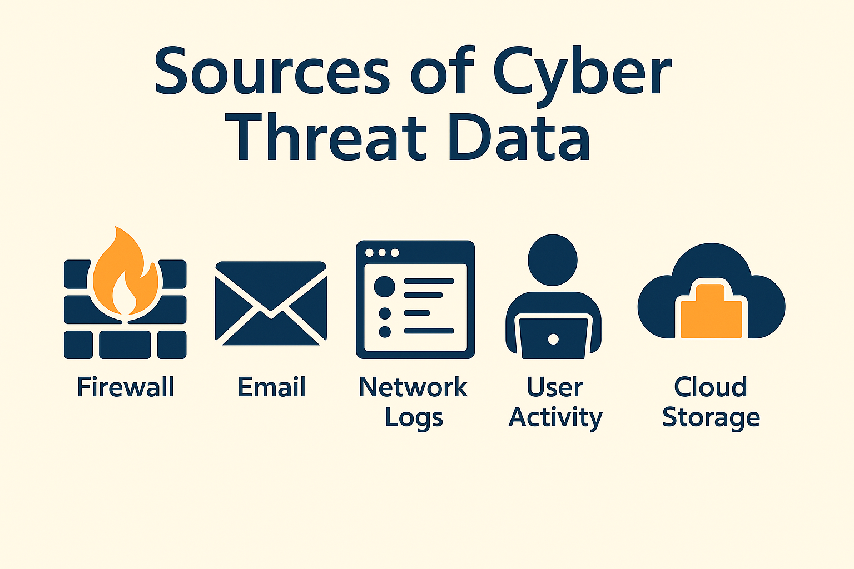
Figure 5: “Sources of Cyber Threat Data”
Learn by Watching
To reinforce your understanding, watch the following video tutorial
How Generative AI can be used in Cybersecurity

Hands-on project (How to make a free mobile app for business)
- Conceptualize a small business idea and use the steps below to create a business app
- How to make simple and free mobile app for business (watch and use as a guide to execute the subsequent steps)
- Create a Free Jotform Account (https://www.jotform.com)
- Access the Jotform App Builder
- Design Your App
- Customize the Look and Feel
- Connect Jotform Forms
- Add Pages or Sections (Optional)
- Test Your App
- Publish Your App
Group Exercise
Business applications require cybersecurity to protect sensitive data and ensure smooth operations. Robust security measures are needed to prevent data breaches, unauthorized access, and disruptions caused by cyberattacks. Break into groups and each group is expected to conceptualizing a business idea, and develop a simple mobile application for their business idea based on the steps above.

Wrap-Up & Takeaways (10 mins)
- Share Ideas: Brief description of knowledge gained.
- Toolkit Recap: Google phishing quiz, JotForm.
- Next Steps: Apply in business starting with your business app and the day-to-day communication analysis.

Quiz:
1. A _______ attack involves tricking a user into giving up sensitive information, often through fake emails or websites.
Answer: phishing
2. Which of the following is a type of malware that locks you out of your system until you pay a ransom?
A. Spyware
B. Adware
C. Ransomware
D. Worm
Correct Answer: C
3. A _______ is a malicious program disguised as a legitimate file or software to trick users into installing it.
Answer: Trojan (or Trojan horse)
4. What does the term "social engineering" refer to in cybersecurity?
A. Building social networks
B. Manipulating people into revealing confidential information
C. Creating fake apps
D. Improving software performance
Correct Answer: B
5. What is the purpose of a firewall?
A. To burn viruses
B. To physically secure a server room
C. To block unauthorized access to a network
D. To update software
Correct Answer: C

6. AI does not require any data to detect security threats.
False
7. Which of the following AI techniques is commonly used in threat detection?
A. Machine learning
B. Video editing
C. Animation rendering
D. Sound processing
Correct Answer: A
8. By analyzing user behavior and detecting anomalies, AI can help identify potential _______ before they cause damage.
Answer: threats
9. How does AI improve phishing detection?
A. By blocking email servers
B. By scanning email content and identifying suspicious patterns
C. By sending auto-replies
D. By deleting all emails
Correct Answer: B
10. What is "User Behaviour Analytics" (UBA) in the context of AI and threat detection?
A. Tracking physical location of users
B. Analyzing patterns in user activity to detect unusual or risky actions
C. Logging out inactive users
D. Sending newsletters
Correct Answer: B
Matching Questions
Column A |  | Column B
1. Intrusion Detection System (IDS) |  | A. Uses algorithms to automatically learn from patterns of malicious activity
2. Machine Learning (ML) |  | B. Identifies and blocks suspicious network traffic in real-time
3. Behavioral Analysis |  | C. Detects unauthorized access attempts to networks or systems
4. Threat Intelligence |  | D. Observes user/system habits to detect abnormal behavior
5. Natural Language Processing (NLP) |  | E. Uses data from multiple sources to identify emerging cyber threats
6. AI-Powered Endpoint Security |  | F. Automatically scans and filters phishing emails for malicious intent
7. Predictive Analytics |  | G. Forecasts potential cyberattacks before they occur
8. Deep Learning |  | H. Improves accuracy in detecting malware by analyzing large datasets
9. Automated Incident Response |  | I. Takes immediate pre-programmed actions after detecting a threat
10. AI in Phishing Detection |  | J. Interprets and analyzes unstructured text to detect suspicious content
Answer Key
1 → C
2 → A
3 → D
4 → E
5 → J
6 → B
7 → G
8 → H
Conclusion
This module has presented to us a concise description of cybersecurity, the key concepts, cyber threat types and how to detect phishing attempts which is becoming widespread in business email compromise and social engineering attempts. It also describes the importance of AI in reinforcing the capabilities of cybersecurity tools for real time detection of threats.

